Ekstra figurer. Noen dere syns det er verdt å ha med?

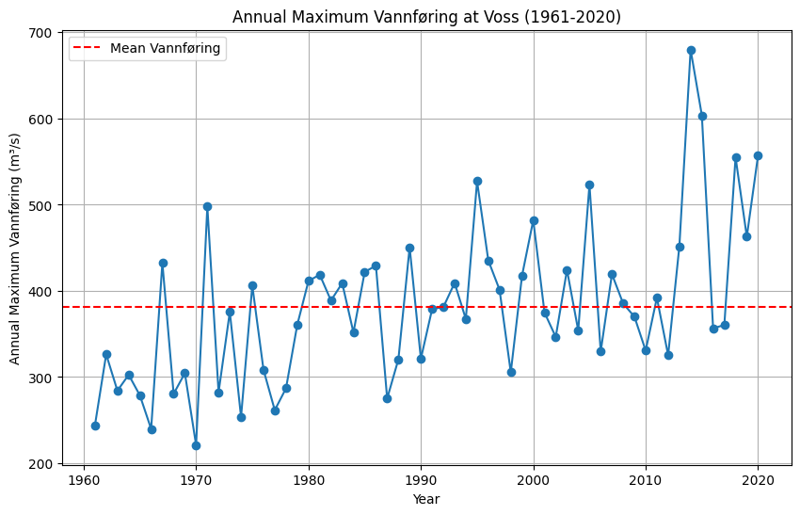

Figure Annual maximum flood values from 1961 - 2020 for Bulken. The blue line represents the annual maximum discharge value. The red dotted line represents the mean of the maximum annual discharge calculated from the whole period.

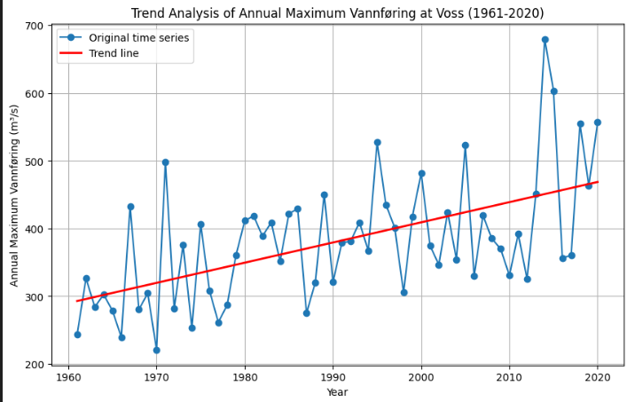
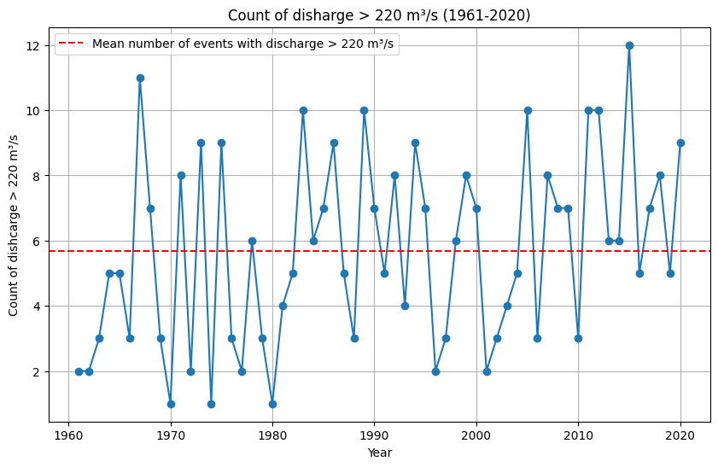 Figure Count of events with flow higher than 220 m3/s for 1961-2020. Red line shows the average number of events.

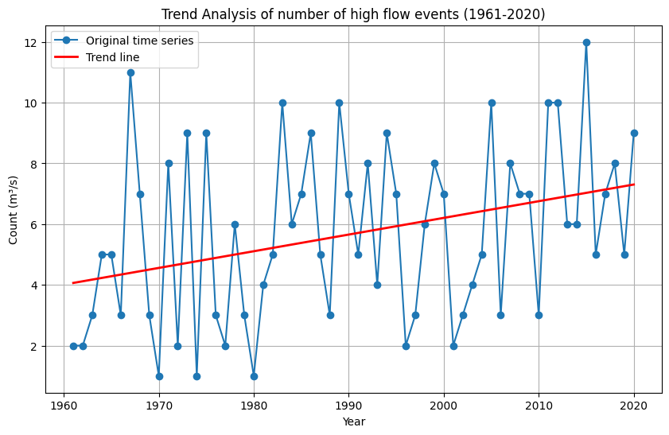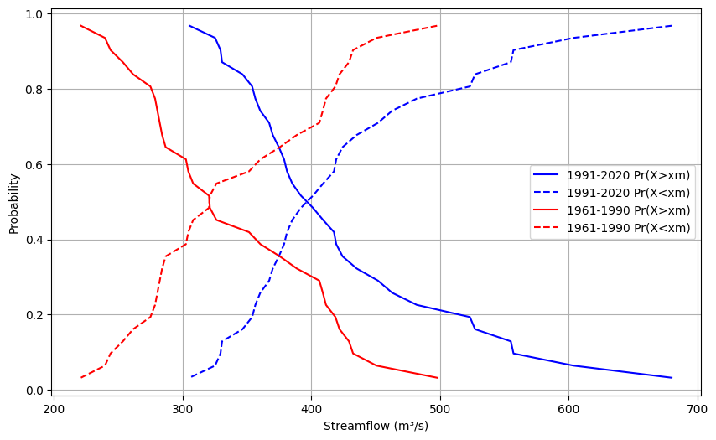
Distribution of data (Q = annumaximum)
Annual max mean (1991-2020): 423.61845666666653 Std: 90.134578291539
Annual max mean (1961-1990): 338.1825733333334 Std: 73.65237370977322
1991-2020
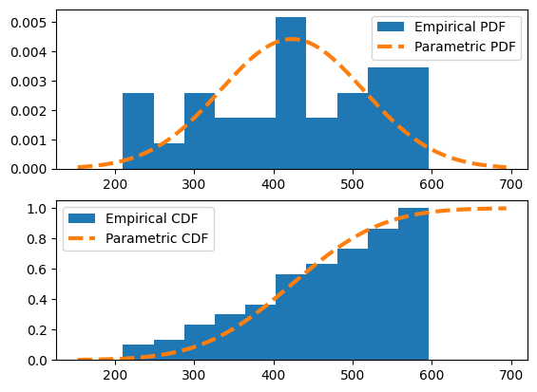
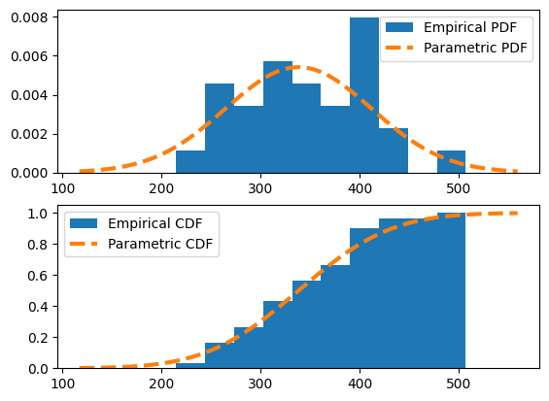

Table 1 Linear regression (OLS) results from analysing annual maximum discharge between 1961-2020.

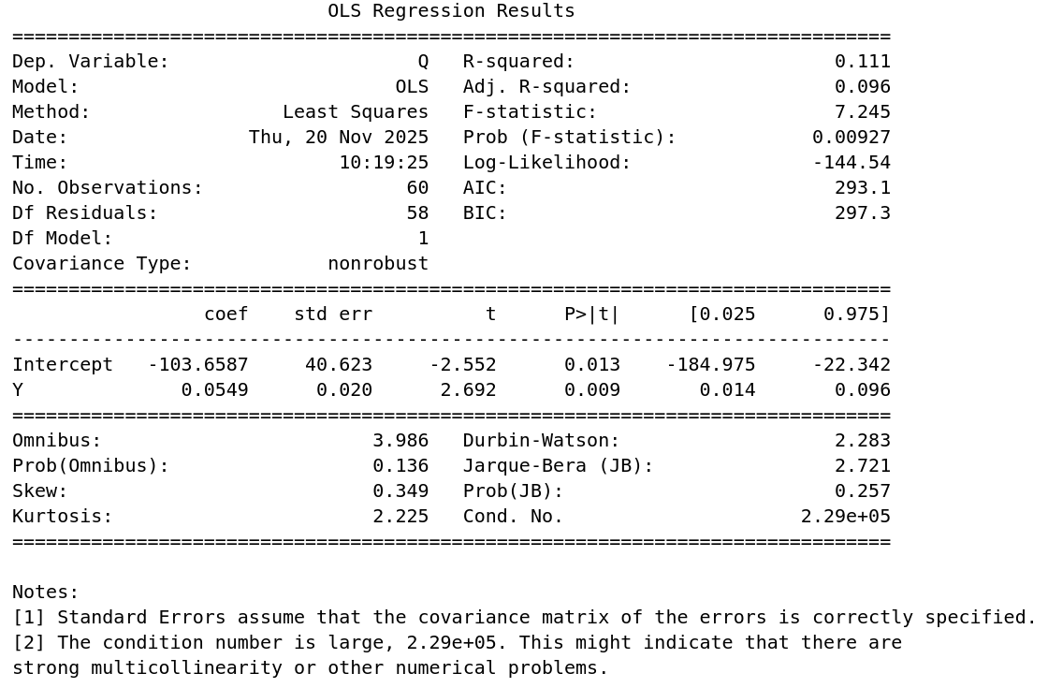
Error of ML model plotted against Measured values
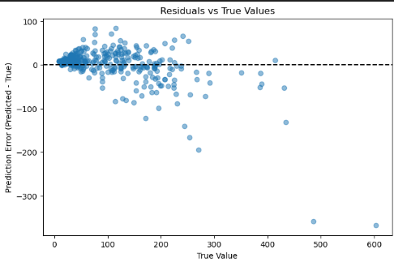
The model struggles *more* with flood events.
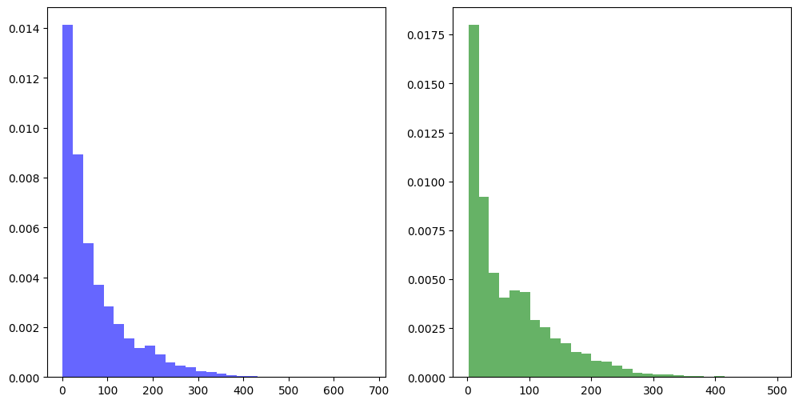
Figure Histogram of daily discharge values in 1961-1990 (blue) and 1991-2020 (green).
Table 3 A comparison of descriptive statistics between period 1961-1990 and 1991-2020.
 | Value | 1961-1990 | 1991-2020
Measures of central tendency | Mean | 68.84 | 71.57
Measures of central tendency | Median | 43.80 | 43.49
Measures of central tendency | Mode | 17.70 | 13.29
Measures of dispersion | Variance | 4701.33 | 5672
Measures of dispersion | Standard deviation | 68.57 | 75.32
Measures of dispersion | Range | 495.60 | 678.84
Measures of dispersion | Coefficient of variation | 0.99 | 1.05
Measures of symmetry | Skewness | 1.47 | 1.88
Measures of symmetry | Kurtosis | 2.29 | 4.46

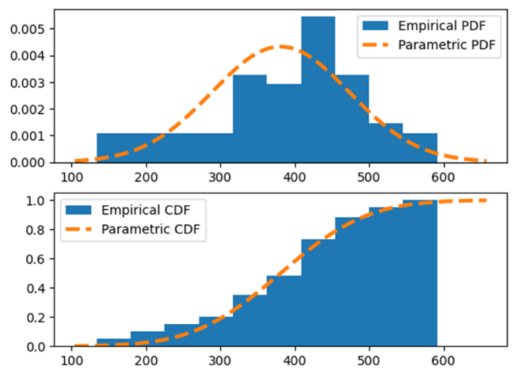 | 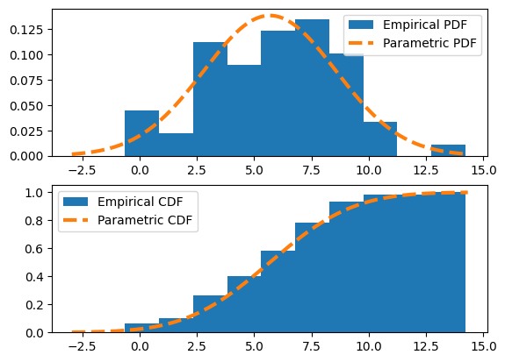
Figure Probability and cumulative density function of the annual maximum flood values and the fitted normal distribution probability and cumulative density function of the same values (left) and probability and cumulative density function of the frequency of high flow events.

Table Results from Linear regression and Mann-Kendall trend test for the two tests: is there a trend in the magnitude of annual maximum discharge and is there a trend in the frequency of high flow events.
Magnitude of annual maximum discharge
Mann-Kendall
Trend=increasing | Flow values increase with time
H=true | The trend is statistically significant
P=0.00022 | P < 0.05 the trend is significant at 95 % confidence interval.
Tau=0.37 | Moderate positive trend
Slope=2.68 | The flow is increasing about 2.68 m3/s per year on average.
z-value=4.23 | Z > 1.96. Significant.
Simple linear regression
Y-coef = 2.98 | The flow is increasing about 2.98 m3/s per year on average.
P-value(Y)0.000003 | |P| > t. P-value smaller than significance level. There is a trend.
Frequency of high flow events (Q > 220 m3/s)
Mann-Kendall
Trend=increasing | Number for flow events increase with time.
H=true | The trend is statistically significant.
P=0.0085 | p < 0.05 the trend is significant at a 95 % confidence interval
Tau=0.23 | Weak to moderate positive trend
Slope=0.05 | The frequency is increasing about 0.05 counts per year on average.
Z=2.63 | Z > 1.96. Significant.
Simple linear regression
Y-coef=0.0549 | The frequency is increasing about 0.05 times per year on average.
P-value(Y)=0.009 | |P| > t. P-value smaller than significance level. There is a trend.

